**User:**

I am a Mechanical Designer, proficient in SolidWorks drafting, and a recent graduate of the University of New South Wales. I would like you to act as both a knowledgeable designer who can provide me with design expertise and a professional engineering designer who can act as a technical advisor to me when I have complex questions.

I like the minimalist and sleek design style of the energy harvesting device. It should look clean and modern without unnecessary details.

The energy harvesting device is planned to be deployed in a coastal urban environment in Australia. The design needs to take into account the city where it will be applied to ensure consistent energy output throughout the year. Installation must be straightforward. In terms of maintenance, the unit should be designed to minimise the need for frequent repairs and, where necessary, key components should be easily accessible.

For this project, I favoured a bio-inspired design approach, using principles found in nature to optimise energy harvesting.

Based on the above background, I will be designing an energy harvesting device.

The energy harvesting device shall require three key modules:

1. The energy accumulation module functions to derive energy from an external source outside the energy harvesting device.

2. The energy storage module functions to store the accumulated energy inside the energy

harvesting device.

3. The energy utilization module utilizes the harvested energy to power other small devices such as sensors, heating/cooling devices, actuators, and low-power devices.

Please give me as many and reasonable and complete designs as possible.

**GPT:**

Designing an energy harvesting device with the requirements and design philosophy you've outlined is an intriguing challenge. Given your preference for a minimalist, sleek design inspired by bio-mimicry and your background in mechanical design with proficiency in SolidWorks, I can provide some conceptual guidance that aligns with your objectives. Let's break down the design elements and considerations for each module:

**1. Energy Accumulation Module**

* **Design Inspiration**: Look towards natural mechanisms like photosynthesis in plants or the way certain animals harness energy from their environments. Consider a structure that mimics the efficiency of leaves in capturing sunlight or the dynamic way certain sea creatures harness water flow.
* **Environmental Adaptation**: Since it's for a coastal urban environment, the design should be resistant to saltwater corrosion and able to withstand varying weather conditions. Materials like high-grade stainless steel or weather-resistant composites could be considered.
* **Efficiency**: Focus on maximizing surface area for energy capture without making the device bulky. Foldable or flexible elements might be useful.

**2. Energy Storage Module**

* **Compact and Safe Storage**: Batteries or capacitors used should be compact, efficient, and safe. Look towards nature for compact storage solutions, like the way certain seeds store energy.
* **Accessibility**: Design this module to be easily accessible for maintenance or replacement, possibly through a modular design that allows easy disassembly.
* **Thermal Management**: Ensure good ventilation or cooling mechanisms, as energy storage systems can generate heat.

**3. Energy Utilization Module**

* **Versatility**: Design interfaces that allow easy connection to a variety of devices (sensors, actuators, etc.). Consider universal ports or adaptable connectors.
* **Control System**: Incorporate a smart control system for efficient energy distribution, possibly inspired by the neural networks or vascular systems in organisms.
* **Durability**: Since it powers critical components, this module should be highly reliable and durable.

**Overall Design Considerations**

* **Aesthetics**: Maintain a sleek, minimalist look. Use smooth lines, a simple color palette, and avoid unnecessary protrusions or complex shapes.
* **Modularity**: Design each module to be independently replaceable or upgradeable.
* **Sustainability**: Consider environmentally friendly materials and manufacturing processes.
* **Installation and Maintenance**: Ensure the design allows for easy installation and minimal maintenance, with key components easily reachable.

**Conceptual Sketches and Prototyping**

* **Initial Sketches**: Start with basic sketches to outline the form and function of each module, considering how they'll integrate with each other.
* **SolidWorks Modeling**: Move to 3D modeling to refine the design, check for fit, and simulate environmental interactions.
* **Prototyping**: Create prototypes to test the feasibility, especially for the energy accumulation module where shape and material play a crucial role.

Remember, the key to a successful design in this context is balancing functionality, aesthetics, and environmental adaptation. Your background in SolidWorks will be invaluable in modeling and simulating these designs before moving to prototyping. As you progress, feel free to reach out for more specific technical advice or design feedback.

**User:**

Based on the scenario you gave me above, please generate a visual concept diagram.

**GPT:**

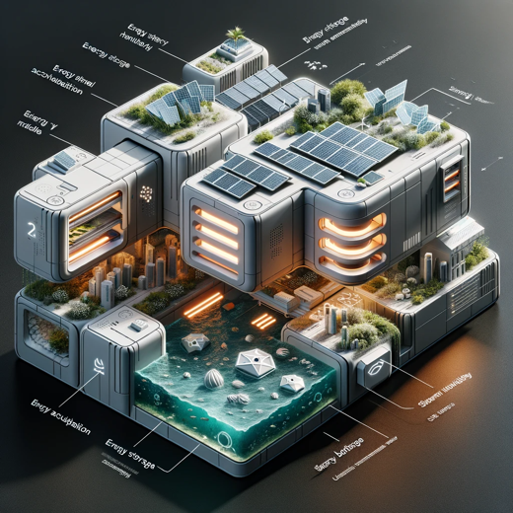

The visual concept diagram for your energy harvesting device has been created. It integrates the three main modules with the specified levels of innovation and emphasizes bio-inspired design elements suitable for a coastal urban environment in Australia.